Name ___________ Date ____

BIO SOL Review 8 - Energy - Food Webs (8)

- (2006-25) A mushroom and a humpback whale are alike because both are —
  - motile
  - prokaryotic
  - unicellular
  - heterotrophic

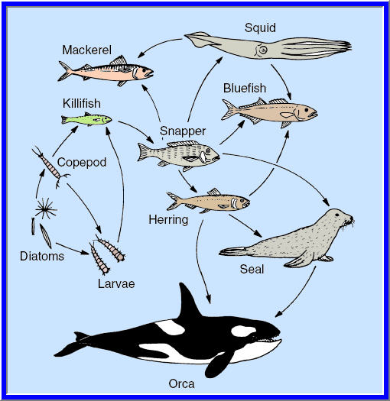
- (2006-48) In the diagram, which organism provides nutrients for the largest number of other organisms?
  - Bluefish
  - Seal
  - Snapper
  - Herring

- (2004-20) Based on the method by which they get food, organisms are classified as autotrophs or heterotrophs. Which organism listed below is correctly paired with its metabolism?
  - Human-heterotroph
  - Fish-autotroph
  - Grass-heterotroph
  - Mushroom-autotroph

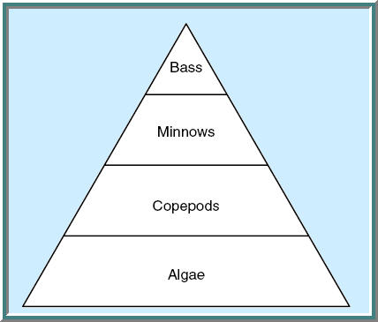
- (2001-36) Which level of this food pyramid represents the largest biomass?
  - Bass
  - Algae
  - Minnows
  - Copepods

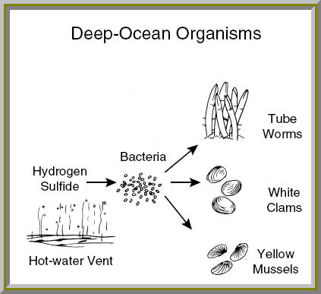
- (2002-29) Around hot-water vents deep in the ocean live specialized communities. Bacteria turn hydrogen sulfide into sugars by a chemical process. The bacteria then provide food to other life forms, as shown in the diagram. Compared to food chains on land, the bacteria fill the same role as —
  - mushrooms
  - hawks
  - green plants
  - rabbits
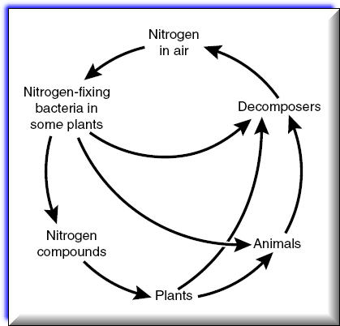
- (2002-27) Which of these is a decomposer in a Virginia forest?
  - A pine tree
  - A dandelion
  - A mushroom
  - A caterpillar

- (2003-34) Which is required by all living things?
  - Oxygen
  - Energy
  - Mobility
  - Carbon dioxide

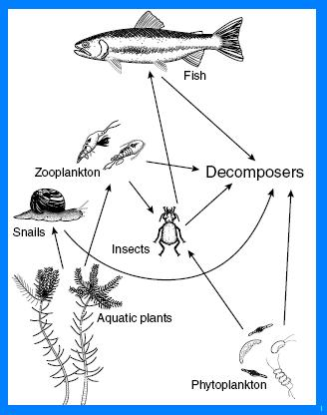
- (2003-37) Energy is transferred from insects to fish in this system by —
  - decaying processes
  - radiation
  - water
  - food consumption

