Name ___________________ Date _______

BIO SOL Review 10 - Macromolecules - Enzymes (10 Questions)

- (2006-36) Which of the following macromolecules are a prominent part of animal tissues that function in insulation, helping animals conserve heat?
  - Carbohydrates
  - Lipids
  - Proteins
  - Nucleic acids

- (2006-18) What is the function of enzymes in biological systems?
  - Enzymes act as products to create new chemical reactions.
  - Enzymes act as substrates when the necessary proteins are unavailable.
  - Enzymes bond with substrates to create the new reaction products.
  - Enzymes act as catalysts to drive chemical reactions forward.
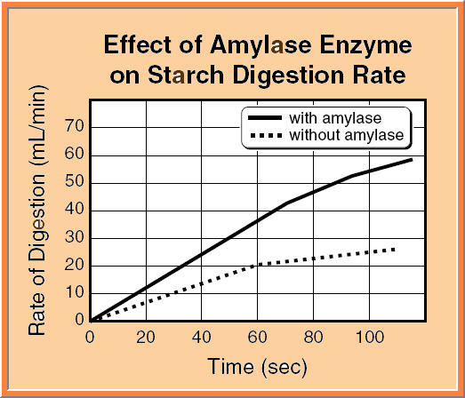
- (2001-27) According to the graph, addition of the enzyme amylase causes the reaction to —
  - slow down
  - speed up
  - take in heat
  - give off heat

- (2002-22) Peroxidase is an enzyme that breaks down hydrogen peroxide in cells. It accomplishes this because of its structure. What part of the enzyme is involved in catalytic activity?
  - Quaternary structure
  - Active site
  - Binding pocket
  - Pleated sheet

- (2004-43) Proteins are formed from monomers (subunits) called —
  - nucleic acids
  - fatty acids
  - nucleotides
  - amino acids

- (2004-16) Enzymes only work with specific substrates because each substrate —
  - actively interferes with other substrates around it
  - destroys its specific enzyme
  - can only use a specific ionic bond with the enzyme
  - has a specific activation site for enzyme attachment

- (2005-40) Most cellular activities are processes regulated by the action of —
  - polysaccharides
  - lipids
  - enzymes
  - carbohydrates

- (2005-38) Amino acids link together by peptide bonds to form proteins. In which cellular organelle would this process occur?
  - Mitochondrion
  - Ribosome
  - Lysosome
  - Golgi body

- (2005-19) Both lipids and carbohydrates are important in animal cells because both —
  - provide insulation
  - store energy
  - form cell walls
  - contain nitrogen

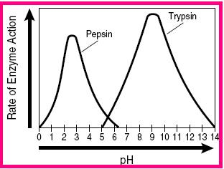
- (2003-19) This graph shows that —
  - more enzymes are present at a higher pH
  - pepsin is less sensitive to pH than trypsin
  - pepsin is less effective at low pH than trypsin
  - pH affects the activity rate of enzymes

